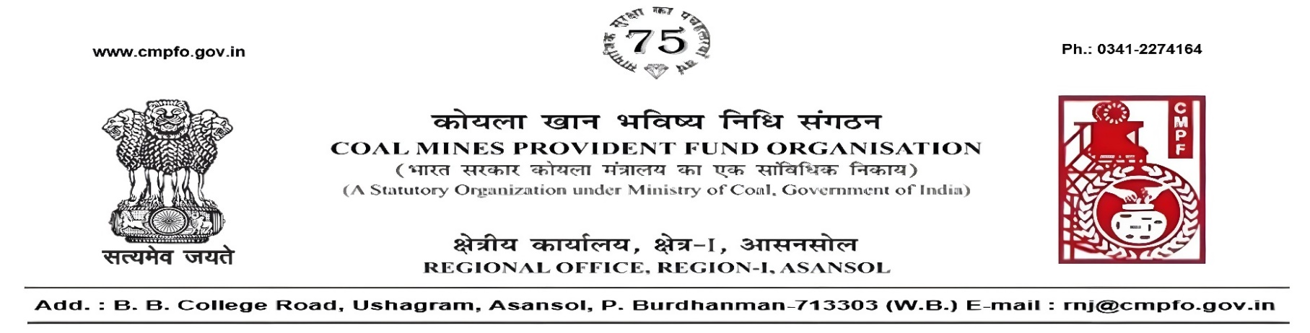
CPF/118/Misc./L.C.-Req./R-I/ASN/ Date-17/08/2026

To,
The Regional Commissioner
Coal Mines Provident Fund Ranchi R-I & II
Darbhanga House CCL HQ.Ranchi University
Morabadi
Ranchi (Jharkhand) 834001

Sub:- Inter Regional Transfer of Ledger Card in respect of Mr. Sanjay Kumar Singh, CMPF a/c No.- RMG/41/179.

Ref:- CPF/BLP/73/L.C.-Req./417 & BLP/65/420 dated 08/06/2026.

Sir,
In view of the revised Procedures prescribed in Procedure Office Order No-35, Dated 12.02.1975 of CMPF Commissioner, Dhanbad, it is stated that the Ledger Cards of the following members along with Declaration in Form A, PS-3 & PS-4 and details of pension contribution may kindly be forwarded to this office in respect of Mr. Sanjay Kumar Singh, CMPF a/c No.- RMG/41/179 working in this region.
It may kindly be ensured that the posting in the Ledger Cards have been made/updated for the periods the member was working in this Region.
In case, the Ledger Card(s) already transferred from your Region, the Region to whom transferred, indicating the details of transfer and your letter number and date be intimated.

SL. No | Place of Posting | From | To | Regional office
1 | Pundi Project, (Kuju Area) CCL | 07/1997 | 08/2007 | Ranchi
Please acknowledge the receipt of the above at the earliest.
Yours faithfully,

(Ajay Kumar Singh)
Regional Commissioner - I

